Ex3.Waveforms

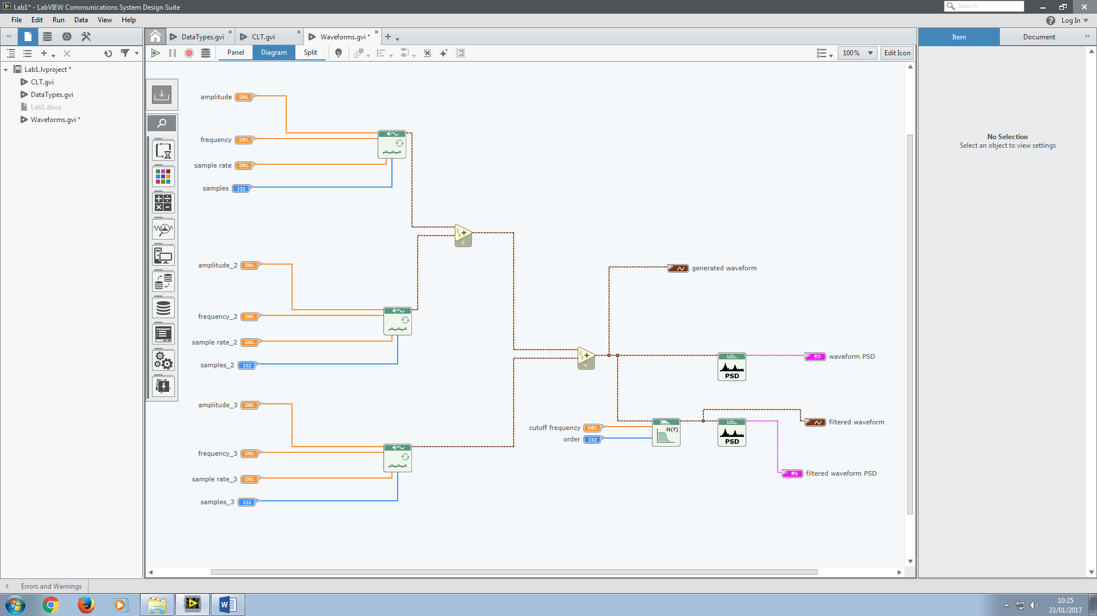

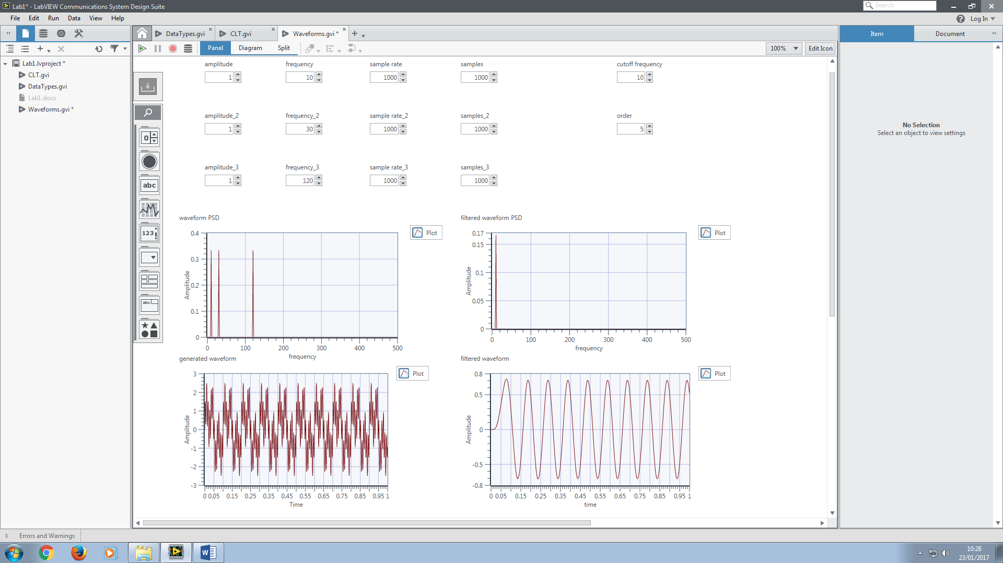

Adjusting the parameter of the filter, we can have a single sine wave at frequency 30 HZ.

This is done by changing the Butterworth low-pass filter into a band-pass filter with low cut-off frequency at 20HZ and high cut-off frequency at 40HZ. Therefore from the PSD we can see that only the 30HZ sine wave component retained and other two are filtered out.

